Experiment No. 1

- Experiment Title: Demonstrate Inline,Internal,External JavaScript, use console methods; create a webpage showing user info and a welcome message.
- Software/Tools Required: VS Code, Html/JS Compiler…
- Experiment Program Code:
Internal:
<!DOCTYPE html>
<html>
<head>
<title>Hello World</title>

<style>
body{
background-color:#ffe4e1;
text-align:center;
font-family:Arial, sans-serif;
padding:40px;
}

h1{
font-size:48px;
color:white;
background-color:#91ff00;
padding:15px;
border-radius:8px;
}

p{
font-size:20px;
color:#333333;
background-color:#ffffcc;
padding:10px;
margin-top:20px;
}

button{
font-size:18px;
color:white;
background-color:green;
padding:12px 24px;
border:none;
border-radius:5px;
cursor:pointer;
margin-top:20px;
}
</style>

</head>
<body>

<h1>Hello World</h1>
<p>Name :Saksham Chimdyalwar, PRN : 24070521151</p>

<p>This is a sample Webpage made using Internal css.</p>

<button>Click Me</button>

</body>
</html>

External:
<!DOCTYPE html>
<html>
<head>
<title>Hello World</title>
<link rel="stylesheet" href="style.css">
</head>
<body>

<h1>Hello World</h1>
<p> Name :Saksham Chimdyalwar, PRN: 24070521151</p>
<p> Sec: C, Sem: 5th </p>

<p>This is a sample Webpage is made by using the External CSS.</p>

<button>Click Me</button>

</body>
</html>

Inline:
<!DOCTYPE html>
<html>
<head>
<title>Hello World</title>
</head>
<body style="background-color:#f0f8ff; text-align:center; font-family:Arial, sans-serif; padding:40px;">

<h1 style="font-size:48px; color:white; background-color:#007BFF; padding:15px; border-radius:8px;">
Hello World
</h1>
<p>
Name : Saksham Chimdyalwar,PRN : 24070521151
</p>
<p style="font-size:20px; color:#333333; background-color:#ffffcc; padding:10px; margin-top:20px;">

This is a sample webpage designed by Inline CSS.
</p>

<button style="font-size:18px; color:white; background-color:green; padding:12px 24px; border:none; border-radius:5px; cursor:pointer; margin-top:20px;">
Click Me
</button>
</body>
</html>
- Output:
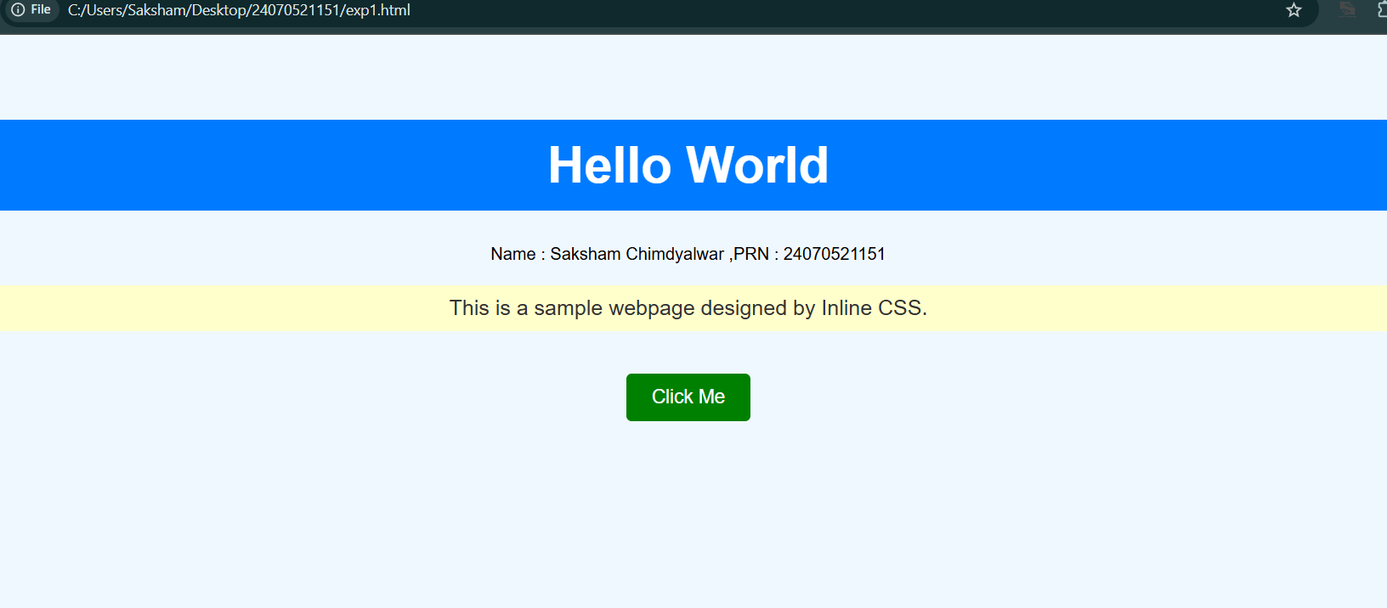

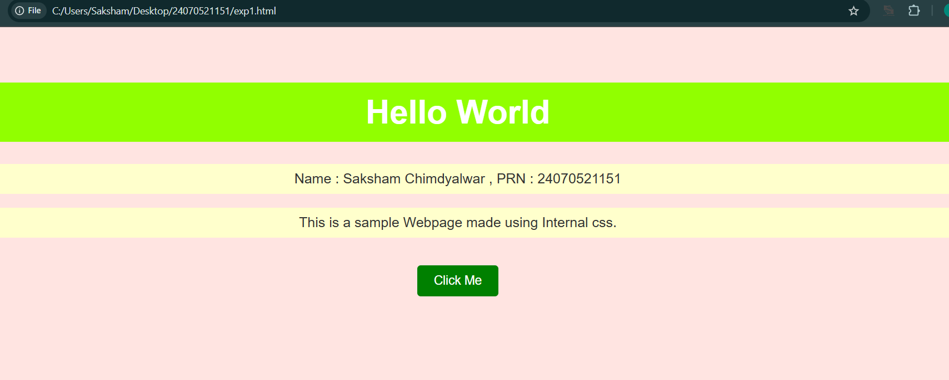

Case Study 1
- Case Study Title: Designing a webpage for SIT Nagpur with buttons , text , images, etc.…
- Case Study Program Code:
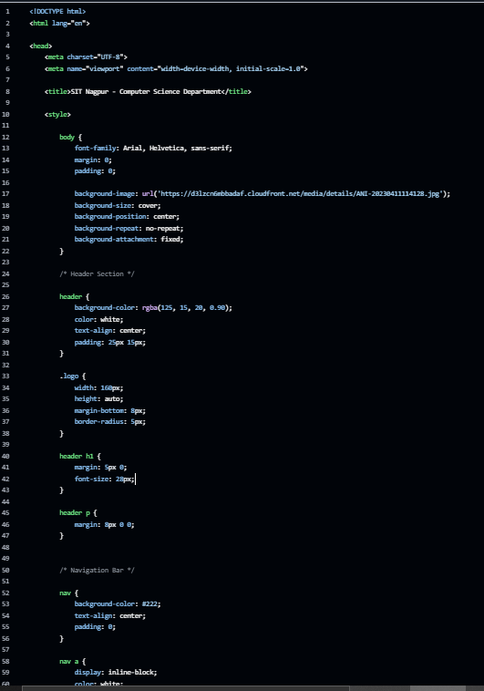

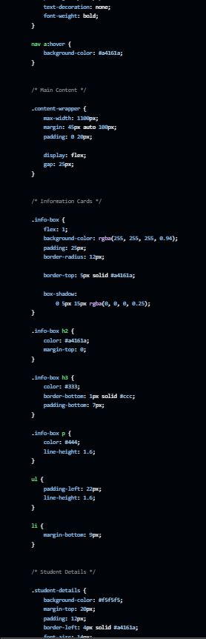

3.Output



Experiment No. 2

- Experiment Title: Use var,let,const and demonstrate basic festures like template literals and destructing; build a billing calculator with user input.
- Software/Tools Required: VS Code, Html/JS Compiler…
- Experiment Program Code:
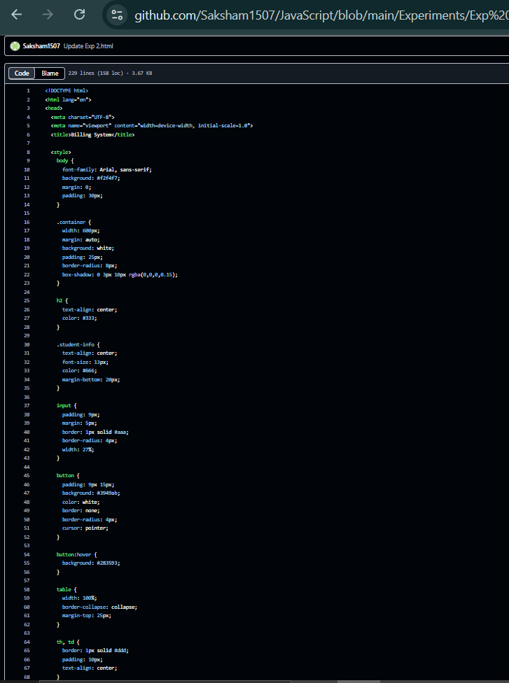

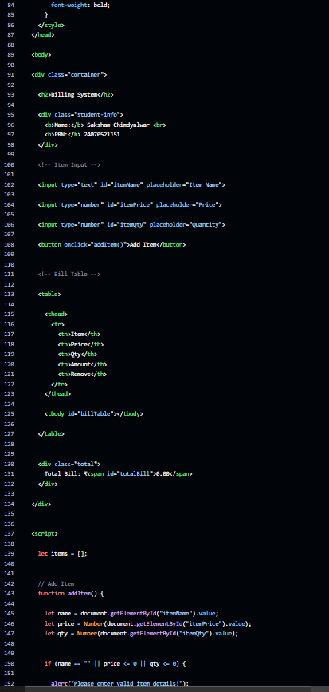

4.Output:

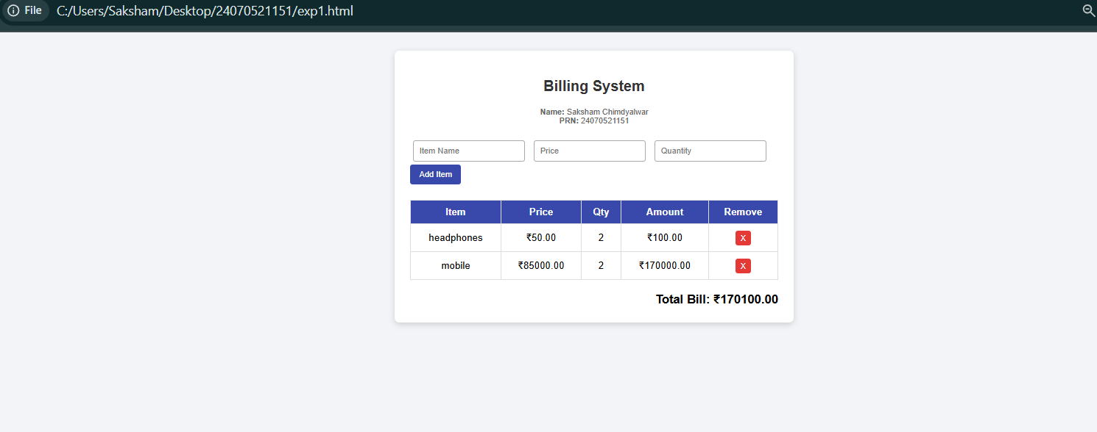

Case Study 2
- Case Study Title: Develop the webpage for an online shopping website using html, css js .

- Case Study Program Code:
<!DOCTYPE html>
<html lang="en">
<head>
<meta charset="UTF-8">
<meta name="viewport" content="width=device-width, initial-scale=1.0">
<title>Online Shopping</title>

<style>
* { box-sizing: border-box; margin: 0; padding: 0; font-family: Arial, sans-serif; }

body { display: flex; min-height: 100vh; background: #eef2f5; }

.products-section { flex: 2; padding: 25px; }
.cart-section { flex: 1; padding: 25px; background: white; border-left: 2px solid #bbb; }

h2 { margin-bottom: 18px; color: #222; }

.student {
margin-bottom: 20px;
font-size: 13px;
color: #555;
}

.grid {
display: grid;
grid-template-columns: repeat(auto-fill, minmax(180px, 1fr));
gap: 18px;
}

.card {
background: white;
padding: 18px;
border-radius: 6px;
border: 1px solid #ccc;
text-align: center;
}

.card h3 { margin-bottom: 8px; }

.price {
color: #7b1fa2;
font-weight: bold;
margin-bottom: 12px;
}

button {
background: #7b1fa2;
color: white;
border: none;
padding: 8px 12px;
border-radius: 4px;
cursor: pointer;
}

button:hover { background: #6a1b9a; }

table {
width: 100%;
border-collapse: collapse;
margin-bottom: 20px;
}

th, td {
text-align: left;
padding: 8px;
border-bottom: 1px solid #ddd;
}

.remove-btn {
background: #e53935;
padding: 4px 8px;
}

.total-box {
font-size: 18px;
font-weight: bold;
display: flex;
justify-content: space-between;
margin-top: 15px;
}

.checkout-btn {
width: 100%;
padding: 10px;
background: #388e3c;
margin-top: 15px;
}

.checkout-btn:hover { background: #2e7d32; }
</style>
</head>

<body>

<!-- PRODUCTS -->
<section class="products-section">

<h2>Online Shopping Store</h2>

<div class="student">
<b>Name:</b> Saksham Chimdyalwar <br>
<b>PRN:</b> 24070521151
</div>

<div class="grid" id="productGrid"></div>

</section>

<!-- CART -->
<section class="cart-section">

<h2>My Cart</h2>

<table>
<thead>
<tr>
<th>Product</th>
<th>Qty</th>
<th>Price</th>
<th></th>
</tr>
</thead>

<tbody id="cartTable"></tbody>
</table>

<div class="total-box">
<span>Total:</span>
<span id="grandTotal">₹0.00</span>
</div>

<button class="checkout-btn" onclick="checkout()">
Place Order
</button>

</section>

<script>

// Product List
const products = [
{ id: 1, name: "Wireless Mouse", price: 1428.00 },
{ id: 2, name: "Keyboard", price: 2856.00 },
{ id: 3, name: "Headphones", price: 4284.00 },
{ id: 4, name: "USB Cable", price: 761.60 }
];

let cart = [];

// Display Products
function renderProducts() {

const grid = document.getElementById("productGrid");

grid.innerHTML = products.map(p => `
<div class="card">
<h3>${p.name}</h3>
<p class="price">₹${p.price.toFixed(2)}</p>
<button onclick="addToCart(${p.id})">Add Item</button>
</div>
`).join('');

}

// Add Item
function addToCart(productId) {

const item = cart.find(i => i.id === productId);

if (item) {
item.qty++;
}
else {
const product = products.find(p => p.id === productId);
cart.push({ ...product, qty: 1 });
}

renderCart();
}

// Remove Item
function removeFromCart(productId) {

cart = cart.filter(i => i.id !== productId);

renderCart();
}

// Display Cart
function renderCart() {

const table = document.getElementById("cartTable");
const totalEl = document.getElementById("grandTotal");

if (cart.length === 0) {

table.innerHTML =
`<tr><td colspan="4" style="text-align:center; color:#777;">No items in cart</td></tr>`;

totalEl.textContent = "₹0.00";

return;
}

table.innerHTML = cart.map(i => `
<tr>
<td>${i.name}</td>
<td>${i.qty}</td>
<td>₹${(i.price * i.qty).toFixed(2)}</td>
<td>
<button class="remove-btn"
onclick="removeFromCart(${i.id})">X</button>
</td>
</tr>
`).join('');

const total = cart.reduce(
(sum, item) => sum + (item.price * item.qty), 0
);

totalEl.textContent = `₹${total.toFixed(2)}`;
}

// Checkout
function checkout() {

if (cart.length === 0) {
alert("Cart is empty!");
return;
}

alert("Order placed successfully!");

cart = [];

renderCart();
}

renderProducts();
renderCart();

</script>

</body>
</html>

3.Output:

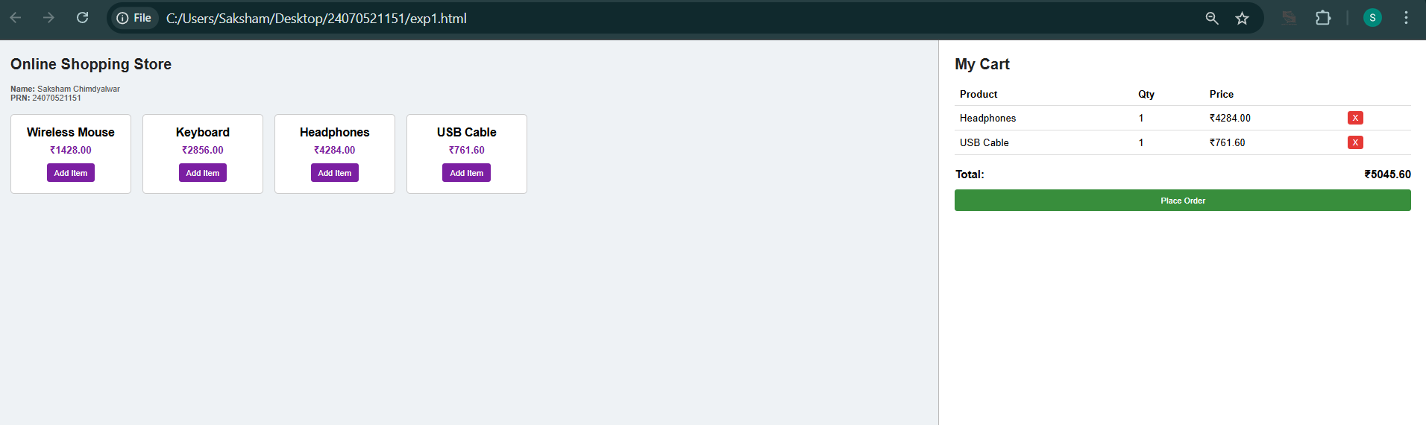

Experiment No. 3

- Experiment Title: Implement control structures and form validations; create a grading system based on user-entered marks.
- Software/Tools Required: VS Code, Html/JS Compiler…
- Experiment Program Code:
- <!DOCTYPE html>
- <html lang="en">
- <head>
- <meta charset="UTF-8">
- <meta name="viewport" content="width=device-width, initial-scale=1.0">
- <title>Student Grade Calculator</title>

- <style>
- * {
- box-sizing: border-box;
- font-family: Arial, sans-serif;
- }

- body {
- margin: 0;
- min-height: 100vh;
- display: flex;
- justify-content: center;
- align-items: center;
- background-color: #eef2f7;
- }

- .container {
- width: 430px;
- background-color: white;
- padding: 30px;
- border-radius: 12px;
- box-shadow: 0 5px 18px rgba(0,0,0,0.15);
- }

- h2 {
- text-align: center;
- color: #222;
- margin-top: 0;
- }

- .student {
- text-align: center;
- font-size: 13px;
- color: #555;
- margin-bottom: 20px;
- }

- label {
- display: block;
- margin-top: 12px;
- margin-bottom: 5px;
- font-weight: bold;
- }

- input {
- width: 100%;
- padding: 9px;
- border: 1px solid #aaa;
- border-radius: 5px;
- }

- button {
- width: 100%;
- margin-top: 20px;
- padding: 11px;
- background-color: #3949ab;
- color: white;
- border: none;
- border-radius: 6px;
- font-size: 16px;
- cursor: pointer;
- }

- button:hover {
- background-color: #303f9f;
- }

- #result {
- display: none;
- margin-top: 20px;
- padding: 15px;
- border-radius: 7px;
- background-color: #e8f5e9;
- line-height: 1.7;
- }

- .fail {
- background-color: #ffebee !important;
- }
- </style>
- </head>

- <body>

- <div class="container">

- <h2>Student Grade Calculator</h2>

- <div class="student">
- <b>Name:</b> Saksham Chimdyalwar |
- <b>PRN:</b> 24070521151
- </div>

- <label>Mathematics</label>
- <input type="number" id="math" placeholder="Enter marks (0-100)">

- <label>Science</label>
- <input type="number" id="science" placeholder="Enter marks (0-100)">

- <label>English</label>
- <input type="number" id="english" placeholder="Enter marks (0-100)">

- <label>History</label>
- <input type="number" id="history" placeholder="Enter marks (0-100)">

- <label>Computer Science</label>
- <input type="number" id="computer" placeholder="Enter marks (0-100)">

- <button onclick="calculateGrade()">Calculate Result</button>

- <div id="result"></div>

- </div>

- <script>

- function calculateGrade() {

- let math = Number(document.getElementById("math").value);
- let science = Number(document.getElementById("science").value);
- let english = Number(document.getElementById("english").value);
- let history = Number(document.getElementById("history").value);
- let computer = Number(document.getElementById("computer").value);

- let marks = [math, science, english, history, computer];

- // Validate marks
- for (let i = 0; i < marks.length; i++) {

- if (marks[i] < 0 || marks[i] > 100) {
- alert("Marks must be between 0 and 100.");
- return;
- }
- }

- let total = math + science + english + history + computer;

- let percentage = total / 5;

- let grade;
- let status = "PASS";

- // Check if student failed any subject
- let failed = false;

- for (let i = 0; i < marks.length; i++) {
- if (marks[i] < 40) {
- failed = true;
- }
- }

- if (failed) {

- grade = "F";
- status = "FAIL";

- } else if (percentage >= 90) {

- grade = "A+";

- } else if (percentage >= 80) {

- grade = "A";

- } else if (percentage >= 70) {

- grade = "B";

- } else if (percentage >= 60) {

- grade = "C";

- } else if (percentage >= 50) {

- grade = "D";

- } else {

- grade = "F";
- status = "FAIL";
- }

- let resultBox = document.getElementById("result");

- resultBox.innerHTML =
- "<b>Name:</b> Saksham Chimdyalwar<br>" +
- "<b>PRN:</b> 24070521151<br><br>" +
- "<b>Total Marks:</b> " + total + " / 500<br>" +
- "<b>Percentage:</b> " + percentage.toFixed(2) + "%<br>" +
- "<b>Grade:</b> " + grade + "<br>" +
- "<b>Status:</b> " + status;

- resultBox.style.display = "block";

- if (status === "FAIL") {
- resultBox.classList.add("fail");
- } else {
- resultBox.classList.remove("fail");
- }
- }

- </script>

- </body>
- </html>

4.Output:

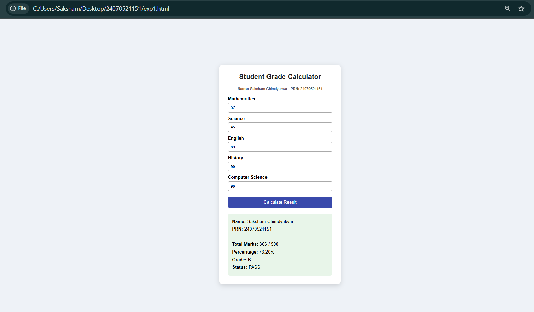

Case Study 3
- Case Study Title: Desing a webpage that match password with the user password, if matched it displays result, if not result not displayed.
- Case Study Program Code:
- <!DOCTYPE html>
- <html lang="en">
- <head>
- <meta charset="UTF-8">
- <meta name="viewport" content="width=device-width, initial-scale=1.0">
- <title>Student Result Portal</title>

- <style>
- * {
- box-sizing: border-box;
- margin: 0;
- padding: 0;
- font-family: Arial, sans-serif;
- }

- body {
- display: flex;
- min-height: 100vh;
- background: #f2f4f7;
- }

- /* Left Section */
- .section-left {
- flex: 1;
- padding: 40px 20px;
- background: white;
- border-right: 2px solid #ccc;
- display: flex;
- justify-content: center;
- align-items: center;
- }

- /* Right Section */
- .section-right {
- flex: 1;
- padding: 40px 20px;
- background: #eef2ff;
- display: flex;
- justify-content: center;
- align-items: center;
- }

- .box {
- width: 100%;
- max-width: 320px;
- }

- h2 {
- margin-bottom: 20px;
- color: #333;
- }

- .student-info {
- font-size: 13px;
- color: #666;
- margin-bottom: 20px;
- line-height: 1.6;
- }

- label {
- display: block;
- font-weight: bold;
- margin-bottom: 8px;
- }

- input {
- width: 100%;
- padding: 10px;
- border: 1px solid #aaa;
- border-radius: 5px;
- font-size: 16px;
- margin-bottom: 15px;
- }

- button {
- width: 100%;
- padding: 10px;
- background: #5e35b1;
- color: white;
- border: none;
- border-radius: 5px;
- font-size: 16px;
- cursor: pointer;
- }

- button:hover {
- background: #4527a0;
- }

- .error {
- color: #b71c1c;
- background: #ffcdd2;
- padding: 8px;
- border-radius: 5px;
- margin-top: 12px;
- display: none;
- text-align: center;
- }

- .placeholder {
- color: #666;
- font-size: 16px;
- }

- /* Result Box */
- .result-card {
- display: none;
- background: white;
- border: 2px solid #43a047;
- border-radius: 10px;
- padding: 30px;
- text-align: center;
- width: 260px;
- }

- .status {
- background: #c8e6c9;
- color: #1b5e20;
- padding: 5px 15px;
- border-radius: 10px;
- font-weight: bold;
- display: inline-block;
- margin-bottom: 15px;
- }

- .gpa {
- font-size: 45px;
- font-weight: bold;
- color: #5e35b1;
- }

- .label {
- color: #555;
- font-size: 14px;
- font-weight: bold;
- }
- </style>
- </head>

- <body>

- <!-- LEFT SIDE -->
- <div class="section-left">

- <div class="box">

- <h2>Student Result Login</h2>

- <div class="student-info">
- <b>Name:</b> Saksham Chimdyalwar<br>
- <b>PRN:</b> 24070521151
- </div>

- <form id="loginForm">

- <label>Password</label>

- <input
- type="text"
- id="passInput"
- placeholder="Enter your password"
- required
- >

- <button type="submit">View Result</button>

- </form>

- <div id="errorMsg" class="error">
- Wrong Password!
- </div>

- </div>

- </div>

- <!-- RIGHT SIDE -->
- <div class="section-right">

- <div id="placeholder" class="placeholder">
- Enter correct password to view your result
- </div>

- <div id="resultCard" class="result-card">

- <span class="status">PASS</span>

- <div class="gpa">9</div>

- <div class="label">GPA</div>

- </div>

- </div>

- <script>

- const TARGET_PASS = "Saksham1151";

- document.getElementById("loginForm").addEventListener("submit", function(e) {

- e.preventDefault();

- const inputVal =
- document.getElementById("passInput").value.trim();

- const isCorrect = (inputVal === TARGET_PASS);

- document.getElementById("errorMsg").style.display =
- isCorrect ? "none" : "block";

- document.getElementById("resultCard").style.display =
- isCorrect ? "block" : "none";

- document.getElementById("placeholder").style.display =
- isCorrect ? "none" : "block";

- });

- </script>

- </body>
- </html>

3.Output:

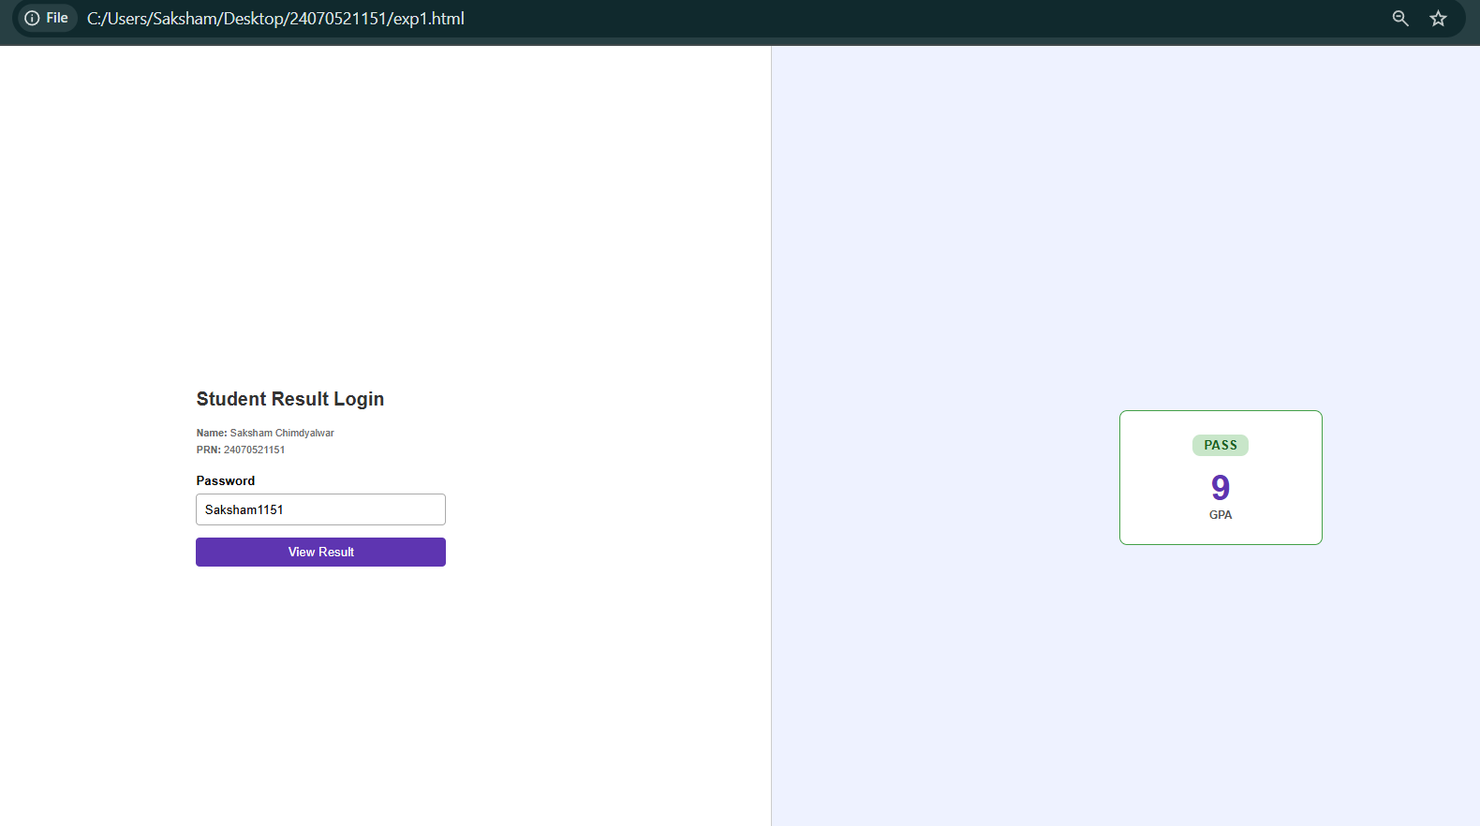

Experiment No. 4

- Experiment Title: Use Function types, scope, and closures; apply try and catch; build a palindrome checker.
- Software/Tools Required: VS Code, Html/JS Compiler…
- Experiment Program Code:
<!DOCTYPE html>
<html lang="en">

<head>
<meta charset="UTF-8">
<meta name="viewport" content="width=device-width, initial-scale=1.0">

<title>Palindrome Finder</title>

<style>
body {
font-family: Arial, sans-serif;
background-color: #eaf2f8;
display: flex;
justify-content: center;
align-items: center;
height: 100vh;
margin: 0;
}

.box {
background-color: white;
width: 400px;
padding: 30px;
border-radius: 10px;
box-shadow: 0 5px 15px rgba(0,0,0,0.15);
text-align: center;
}

h2 {
margin-top: 0;
color: #222;
}

.info {
font-size: 13px;
color: #666;
margin-bottom: 20px;
}

input {
width: 100%;
padding: 11px;
margin-bottom: 15px;
border: 1px solid #aaa;
border-radius: 5px;
font-size: 15px;
}

button {
width: 100%;
padding: 11px;
background-color: #3949ab;
color: white;
border: none;
border-radius: 5px;
font-size: 16px;
cursor: pointer;
}

button:hover {
background-color: #283593;
}

#answer {
margin-top: 20px;
padding: 12px;
border-radius: 6px;
display: none;
font-weight: bold;
}

.correct {
background-color: #d4edda;
color: #155724;
}

.wrong {
background-color: #f8d7da;
color: #721c24;
}
</style>

</head>

<body>

<div class="box">

<h2>Palindrome Checker</h2>

<div class="info">
Name: <b>Saksham Chimdyalwar</b><br>
PRN: <b>24070521151</b>
</div>

<input
type="text"
id="textInput"
placeholder="Enter a word or number"
>

<button onclick="findPalindrome()">
Check Palindrome
</button>

<div id="answer"></div>

</div>

<script>

function findPalindrome() {

let text = document.getElementById("textInput").value;

let answer = document.getElementById("answer");

// Check empty input
if (text === "") {

answer.style.display = "block";
answer.className = "wrong";
answer.innerHTML = "Please enter a word or number.";

return;
}

// Convert input into lowercase
let original = text.toLowerCase();

// Remove spaces
original = original.replace(/\s/g, "");

// Reverse the input
let reversed = original
.split("")
.reverse()
.join("");

// Check palindrome
if (original === reversed) {

answer.style.display = "block";
answer.className = "correct";

answer.innerHTML =
'"' + text + '" is a Palindrome!';

} else {

answer.style.display = "block";
answer.className = "wrong";

answer.innerHTML =
'"' + text + '" is NOT a Palindrome.';
}
}

</script>

</body>
</html>
4.Output;

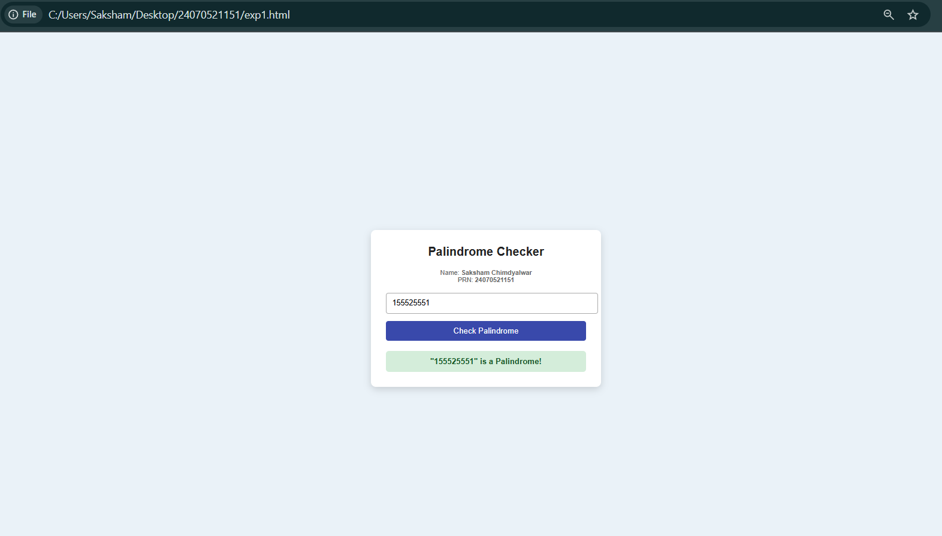

Case Study 4
- Case Study Title: Desing a webpage to check whether the password is Palindrome or not if Palindrome display msg Weak Pass if not display Strong Pass.
- Case Study Program Code:
- <!DOCTYPE html>
- <html lang="en">
- <head>
- <meta charset="UTF-8">
- <meta name="viewport" content="width=device-width, initial-scale=1.0">

- <title>Password Strength Checker</title>

- <style>
- * {
- box-sizing: border-box;
- margin: 0;
- padding: 0;
- font-family: Arial, sans-serif;
- }

- body {
- background: #eef2f5;
- display: flex;
- justify-content: center;
- align-items: center;
- min-height: 100vh;
- }

- .container {
- background: white;
- width: 400px;
- padding: 25px;
- border-radius: 8px;
- border: 1px solid #ccc;
- box-shadow: 0 4px 10px rgba(0,0,0,0.1);
- }

- h2 {
- text-align: center;
- color: #333;
- margin-bottom: 5px;
- }

- .subtitle {
- text-align: center;
- color: #777;
- font-size: 14px;
- margin-bottom: 20px;
- }

- .student-info {
- background: #f5f5f5;
- padding: 8px;
- margin-bottom: 15px;
- font-size: 13px;
- text-align: center;
- }

- .password-box {
- display: flex;
- gap: 5px;
- margin-bottom: 12px;
- }

- input {
- flex: 1;
- padding: 10px;
- border: 1px solid #aaa;
- border-radius: 5px;
- font-size: 15px;
- }

- .show-btn {
- background: #555;
- color: white;
- border: none;
- border-radius: 5px;
- padding: 8px;
- cursor: pointer;
- }

- .check-btn {
- width: 100%;
- padding: 10px;
- background: #3949ab;
- color: white;
- border: none;
- border-radius: 5px;
- cursor: pointer;
- font-size: 15px;
- }

- .check-btn:hover {
- background: #283593;
- }

- #result {
- display: none;
- margin-top: 15px;
- padding: 10px;
- text-align: center;
- border-radius: 5px;
- }

- .warning {
- display: block !important;
- background: #fff3cd;
- color: #856404;
- }

- .success {
- display: block !important;
- background: #d4edda;
- color: #155724;
- }

- .error {
- display: block !important;
- background: #f8d7da;
- color: #721c24;
- }
- </style>
- </head>

- <body>

- <div class="container">

- <h2>Password Security Checker</h2>

- <p class="subtitle">
- Check whether your password is a palindrome
- </p>

- <div class="student-info">
- <b>Name:</b> Saksham Chimdyalwar <br>
- <b>PRN:</b> 24070521151
- </div>

- <div class="password-box">

- <input
- type="text"
- id="passwordInput"
- placeholder="Enter password"
- >

- <button class="show-btn" onclick="togglePassword()">
- Hide
- </button>

- </div>

- <button class="check-btn" onclick="checkPassword()">
- Check Password
- </button>

- <div id="result"></div>

- </div>

- <script>

- let hidden = false;

- // Show or Hide Password
- function togglePassword() {

- const input = document.getElementById("passwordInput");
- const button = document.querySelector(".show-btn");

- if (hidden == false) {

- input.type = "password";
- button.innerHTML = "Show";
- hidden = true;

- } else {

- input.type = "text";
- button.innerHTML = "Hide";
- hidden = false;

- }
- }

- // Check Password
- function checkPassword() {

- const password =
- document.getElementById("passwordInput").value;

- const result =
- document.getElementById("result");

- // Empty Password
- if (password == "") {

- result.className = "error";

- result.innerHTML =
- "Please enter a password first!";

- return;
- }

- // Reverse Password
- const reversedPassword =
- password.split("").reverse().join("");

- // Palindrome Check
- if (password === reversedPassword) {

- result.className = "warning";

- result.innerHTML =
- "<b>Weak Password!</b><br>Password is a palindrome.";

- } else {

- result.className = "success";

- result.innerHTML =
- "<b>Strong Password!</b><br>Password is not a palindrome.";

- }

- }

- </script>

- </body>
- </html>

3.Output:

